VISIT POLAND – THE NATURAL CHOICE

Desperately trying to rid itself of its old Communist cloak, Poland has risen from the ashes as an increasingly popular tourist destination. Many visitors are surprised to discover that Poland is a country full of striking natural scenery.

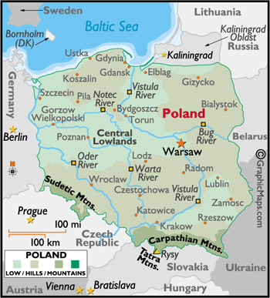

LOCATION :
As the crossroads of Northern Europe, Poland shares borders with Germany, the Czech Republic, Slovakia, Ukraine, Belarus, Lithuania, and Kaliningrad, a detached possession of Russia. To the north, Scandinavia is just a short ferry trip across the Baltic Sea.
Poland's major cities –
- The nation's capital, Warsaw, is located just east of the country's geographic centre.
- Kraków lies in the extreme South of the country, almost on the Slovak border,
- Wroclaw slightly west, near the Czech Republic, and
- Gdansk to the far north, on the Baltic.

VISA The visa is to be obtained prior to arrival in the country

HOW TO GET THERE :
International Airport :
Most international flights arrive at Warsaw's Okecie International Airport.
Airports in Gdańsk,Wrocław and Kracow also have international connections.

GETTING AROUND :
Air : LOT, the Polish national airline, handles the majority of air traffic to and around Poland.
From Warsaw, there are connecting flights to Gdansk, Kraków, Wroclaw.

Train : The train is the easiest way to get around the country.
Polish Railways, or PKP, runs long-distance domestic and international rail travel, with most long-distance trains stopping in Warsaw. PKP trains are old-fashioned, but tolerably clean, and they run almost impeccably on schedule.
PKP trains fall into three categories. Intercity (IC) trains are the fastest, make the fewest stops, and are the most expensive. Express trains are the middle category in both speed and price. Seat reservations are compulsory on both Intercity and Express trains. Fast trains are the slowest of the three. They make frequent stops, and have no reserved seats. Fast trains are very cheap and subsequently tend to be quite crowded.

Bus : Where the trains don't go, the buses do. Eurolines runs coach services to international destinations, and PKS handles most domestic transport.

The following table provides approximate driving distances between selected Polish cities. Kilometres in the lower left of the table, miles in the upper right.
 | War | Gda | Kra | Wro | Osw | Zak | Giz
Warsaw | • | 244 | 244 | 218 | 196 | 258 | 155
Gdansk | 359 | • | 376 | 265 | 342 | 439 | 150
Krakow | 359 | 602 | • | 167 | 39 | 63 | 379
Wrocklaw | 348 | 424 | 267 | • | 136 | 238 | 371
Osweicm | 313 | 547 | 63 | 217 | • | 76 | 350
Zakopane | 413 | 703 | 100 | 381 | 122 | • | 448
Gizycko | 248 | 240 | 607 | 593 | 561 | 717 | •

Ferry : Sea connections between Denmark & Sweden to Gdañsk, Gdynia and OEwinoujoecie.

CURRENCY :
The currency is Zloty (Zlotych) (PLN). PLN1=100 groszy
Currency can be exchanged at airports, banks, major hotels and at border crossings. There are also currency exchange offices named Kantor, which are generally open from 09h00-19h00 Mon-Fri and until 14h00 Sat. Traveller's cheques can be exchanged at banks, major hotels, airports and at border crossings but will not be accepted at Kantors.
You will be charged 1% commission for exchanging traveller's cheques

BUISNESS :
Banks in large towns are usually open from 09h00-16h00 Mon-Fri and until 13h00 Sat. In smaller towns the hours may vary. The largest national bank is PKO BA (Polska Kasa Oszczednosciowa).
Standard opening hours for consumer-goods shops in Poland are 11h00-19h00, though some open at 09h00 and may close at 17h00.
Food shops usually open 08h00-19h00 or 09h00-20h00. Most businesses are closed on Sundays, although general supermarkets, both large and small, tend to stay open.

CLIMATE :
Poland's climate is very pleasant from May until October with temperatures averaging between 18-25 degrees.
The weather tends to be very unpredictable in spring, with temperatures varying from zero to 16 degrees. March and April tend to be windy and wet.
The autumn (October/November) is often pleasant, though, with temperatures dropping slightly after the summer but still generally warm.

TIME :
Poland is 3.30 hrs. behind India (IST).

ELECTRICITY :
Electricity supply is 230 volts. . It's recommended that you purchase your electrical plug adapter prior to arriving into Poland.

DIALLING CODE :
International dialling code: | 48
Area codes: | Warsaw: 22, Kraków: 12, Wrocklaw: 71, Gdansk: 58, Poznan: 61

TIPS :
It is general practice to leave a tip of 10-15% in restaurants and cafés. A small tip may also be left for porters in hotels and at railway stations.

LANGUAGE :
Polish is the official language spoken. German and Englidh

INFORMATIVE WEBSITE :
www.poland.travel

CITIES :

WARSAW :
While most of Poland's capital city consists of Soviet structures, The centre of the city contains its most prominent, not to say looming, building, the Palace of Culture and Science. Constructed by Stalin, ironically, the sructure - which never fails to make an impression, be it good or bad - now overlooks the multitude of development aimed at making Warsaw a more Westernised, Capitalist city.

Accomodation Options in Warsaw :
Accommodation in Warsaw consists predominantly of business-style hotels, most of them housed in 1970s or more modern purpose-built blocks. Most of the major international chains are represented in the city, such as Marriott or Holiday Inn, alongside a number of Polish-owned hotels.
The majority of hotels tend to be clustered around the central railway and metro stations, making them easy to find and convenient for the main sights. One of the best options is the Sofitel Victoria, a short walk east from the train station. It offers all the amenities that you would expect from the international chain, as well as being in a perfect location for a host of attractions including Victory Square, the Opera House and the Saxon Gardens. A slightly cheaper option is the Novotel Centrum, in a similar central location opposite the Palace of Culture and Science, and offering comfort and value for money.

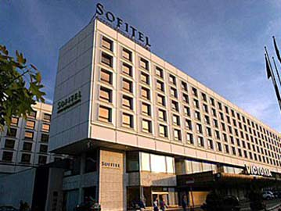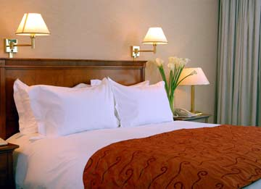

Must – Sees :
Gestapo Headquarters :
Used as the Nazi interrogation command centre during the war, this was the scene of horrific acts of brutality perpetrated against the Poles, many of whom were tortured for days on end within the confines of the building.
There is a museum now within the building, which provides a bleak but interesting account of what went on here.
Open: Thu, Sat 09h00-16h00; Wed 09h00-17h00; Fri 10h00-15h00; Sun 10h00-16h00. Admission: free.

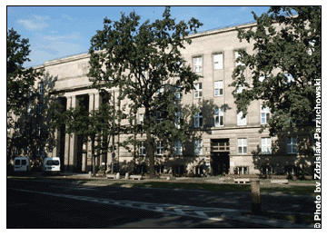

The Old Town :
Though Warsaw's original buildings were almost completely obliterated in the war, the Stare Miasto area has been renovated from top to toe. Much effort went into preserving, or rather recreating, the look and feel of Warsaw prior to its repeated destruction and it's hard to believe that the central square in particular is all a reproduction - truly a masterpiece of architectural engineering.
The area is very pleasant for wandering around and there's plenty to keep the idle passerby amused, including numerous restaurants, cafés and shops. This is also where you'll find the Royal Castle

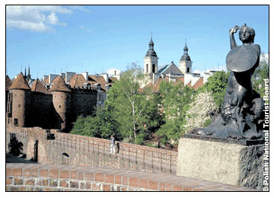

Palace of Culture and Science :
Love it or hate it, you'll have trouble remaining indifferent to the 231-metre-high Palace of Culture and Science, undoubtedly the most iconic structure in Warsaw.
The palace now houses cinemas, theatres and offices as well as a museum and an observation deckonthe30th floor.
Open: 09h00-18h00. Admission: PLN18.

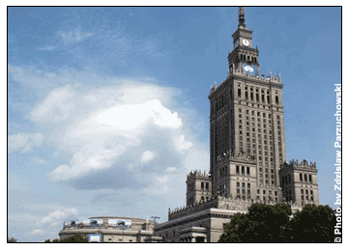

The Palace on Water and Lazienki Park :
The romantically named Palace on the Water stands on a lake in Warsaw's largest green space, Lazienki Park. The 17th-century building was converted into a summer house in 1764.
Dusk or dawn is the ideal time to admire the cascading reflection in the water, though it's worth visiting during the day so that you can enter the palace and enjoy the rest of the park which contains an expansive botanical garden, orangery and further ponds and canals.
Open: Tue-Sun 09h00-15h00. Admission: free

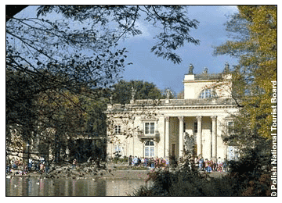

The Royal Castle :
Another bold reconstruction, the Royal Castle was originally founded in the 14th century when it was home to King Sigismund.
The present-day structure and furnishings are a faithful representation of the castle in its 18th-century heyday.
Open: Tue-Sat 10h00-16h00; Sun 11h00-16h00 (Oct-14 Apr); Tue-Sat 10h00-18h00, Sun & Mon open an hour later (15 Apr-Sept). Admission: PLN18; PLN85 for English speaking guide.

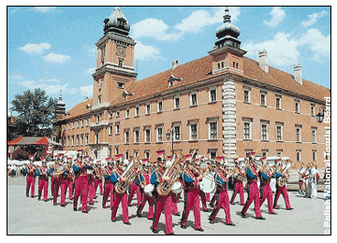

KRAKOW :
Hailed as the new Prague, Krakow has been on the tourist map for a few years now, and it's easy to see why it has become so popular with visitors looking for olde worlde East European charm.

Accomodation Options in Krakow :
Krakow has a good range of hotels dotted around the city, from traditional B&Bs to business hotels and glitzy establishments fit for a Polish king. The prime location is of course around the old town, and if you can get a place near Rynek Glowny, so much the better. Luckily though, Krakow is fairly compact, so even if you're not right in the middle of town, you're usually likely to be within easy walking distance or a short bus ride away.
Naturally, the old town is the most expensive area to stay, and it also gets booked up quickly, especially in summer when hordes of tourists descend on Krakow.
Just on the periphery are a number of decent options such as the Chopin, a reasonably priced, modern hotel about 10 minutes' walk to the east of Stare Miasto.
A bit further out, the Sympozjum is a comfortable, four-star hotel away from the crowds, but still only a short drive or bus ride from the centre.
One of the best alternatives to staying in the old town, especially if you want to take advantage of the nightlife in the area, is the old Jewish quarter of Kazimierz, about 15 minutes' walk from Rynek Glowny and a lively district in its own right.

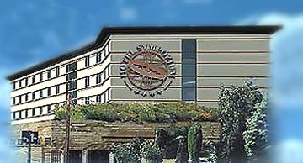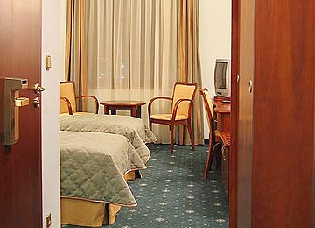

MUST – SEES:
Rynek Glowny :
Krakow's vast main square, Rynek Glowny, has for eight centuries been at the heart of the old town, its perimeter lined with an array of traditional buildings dating predominately from the 13th to 16th centuries. Constantly teeming with life, be it shoppers, tourists, or visitors to local bars and restaurants, this is where most major events take place, from the city festival in June to the Christmas market in December

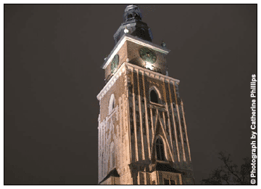

Wawel Castle :
Perched on a hill overlooking the Vistula River, Wawel Castle has served as the main royal residence from the 11th-17th centuries when Krakow was the capital of Poland.
Arguably the most striking part of the exterior is the expansive arcaded courtyard, a perfect example of Renaissance elegance. On your tour of the outside also make a point of visiting the bronze dragon, standing proud guarding the entrance to his den (den open Apr-Oct only, but dragon visible year-round. Admission: PLN3).
There's enough to see within the castle complex to occupy you for several hours, including the cathedral, several historical exhibitions, and the state rooms and royal private apartments. Make sure you allow enough time to see at least one of the latter areas: for pure decadence alone they're hard to beat.
There are a limited number of tickets sold for each area for tours at specific times, so it's worth arriving fairly early in the day or booking in advance from the ticket office to be sure of a place.
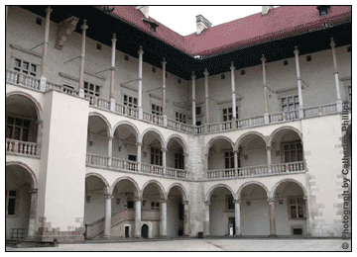

Museum of Jewish History and Culture, Old Synagogue :
Housed in Poland's oldest synagogue, the Museum of Jewish History & Culture is a fascinating collection of artefacts and information detailing the history of the Jewish population, both in Krakow and further afield.

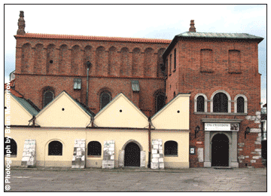

National Museum :
Housed in several buildings dotted around the city, the National Museum is dedicated predominantly to Polish art and culture through the ages.
The notable exception to all this Polishness is the Manggha Centre of Japanese Art and Technology, which has a surprisingly comprehensive collection of traditional Japanese objects and artworks.

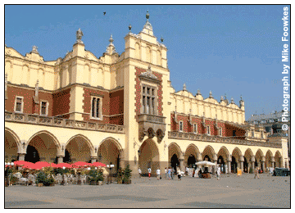

FOOD :

WARSAW :

Indian Restaurants
1. Guru - 18 Bracka St.,ph. 827 27 88,
2. India Curry - 22 ¯urawia St., ph. 438 93 50/51
3. Maharaja - 13 Szeroki Dunaj , ph. 635 25 01

KRAKOW :

Indian Restaurants
1. Bombaj Tandoori - ul. Szeroka 7
2. Indus Tandoor - 13-15 Slawkowska street.

SHOPPING :
While Poland is not the place to come for snazzy, brand-name shopping, visitors can take home plenty of quality souvenirs. Most Polish souvenirs are handmade and represent a deeply ingrained folk culture.

What to Buy :
Carved wooden figurines, typically depicting religious figures or peasants. Stained, painted or left raw, these rough-hewn statuettes are predominant in Kashubia.
Amber jewellery from local artisans. Sometimes called Baltic Gold, amber has been a staple of the Polish economy for thousands of years. In remote locations it is possible to find raw pieces washed up on the beach.
Traditional peasant clothing, brightly-coloured outfits full of character.
Handmade religious folk-art, including wood-and-brass icons, crucifixes and nativity scenes.
Peasant embroidery. Fresh floral motifs and simple backgrounds give Polish embroidered napkins, tablecloths, and curtains an understated pastoral elegance.
High-quality replica weapons and armour, produced by professional blacksmiths. Among the typical medieval and Viking fare are pieces like the crested helmets and winged breastplates of the Hussars, Poland's legendary cavalry.
Smoked mountain cheeses. These salty and intense smoked cheeses, made using an ancient method, are available at the supermarket, but are best bought from street vendors. Remember that some countries will limit the import of dairy products.
Zubrowka. This flavoured vodka is distinctively Polish and difficult to find outside the country. Most of the better brands of Polish clear vodka are exported.
For a unique shopping experience, though you might not actually be tempted to buy much, visit the Russian Market at the Stadion Dziesieciolecia in Warsaw. Housed in an old football stadium, this outdoor bazaar is the largest such market in Europe. Get there early in the morning to gawk at the dirt-cheap pirate CDs, fake Rolexes, and the occasional Kalashnikov, but watch out for pickpockets

